**How To:**

1. **Run coremark**:

CoreMark is a benchmark program – a program that is supposed to test the performance of a CPU. CoreMark is built to minimizes the dependence of the results on compiler optimizations. As a benchmark, CoreMark allows for measurement of how changes in the RTL affect hardware performance. The score is normalized by clock speed, so it is more of a look at efficiency than raw computing power. Note that even though Coremark is compiler independent, implementing a new command that the compiler doesn’t know about will not improve the Coremark score.

* 1. Cd $MY_PULP_APPS/coremark
  2. Source comp_coremark_simtimer.sh - This is a special script because coremark is multiple programs
  3. Cd $MY_PULP_IRUN/
  4. Pulp_get_app coremark - This prepares coremark for simulation
  5. Pulp_irun - simulate coremark
  6. the result is now presented in terms of total ticks
  7. We can now calculate the coremark score:

$$\frac{1}{total ticks}×{10}^{6}$$

Explanation: total ticks is the number of clock cycles to run the coremark program once. If you take the reciprocal, then you get coremark /Hz. We normalize it to get coremark /MHz, which is the standard score

1. **Run waveform**
   1. After app is compiled and ready to run: (You can do this with the script our_pulp_compile)
   2. Pulp_irun_probe (this might take a while …)
   3. Simvision & (opens the simulator)
   4. A screenshot of a cell phone

      Description automatically generatedIn simvision: File->open Database in the browse tab there will be a folder called waves, open it.

The design is under tb/top_i:

To save the signals and markers you add to simvision

* File->save command script
* Choose a save location

How to run the script:

* File-> source command script
* open the relevant script
* when a dialog window opens click ok

1. **Make assembly trace file**
   1. Get ready for simulation (our_pulp_compile)
   2. Run: pulp_irun_trace (must be in sim/irun directory)
   3. The trace file will appear in the irun folder:

Notes:

* The time is the exactly the same as the simulation, but the cycles aren’t necessarily.
* You can use the time to search the waveform.
* The relevant register values in each cycle appear on the right columns.
* The mnemonic is the instruction in assembly.
* Instr column is the same as the mnemonic column written in hex.

1. After a program is compiled, you can run a waveform and trace by using the alias our_wave_trace <name of saved files>. The waveform will be saved in $MY_PULP_APPS/waves with the name you chose when running the script, and the assembly trace will be in $MY_PULP_APPS/trace, also with the chosen name.
2. **Other important files:**
   1. <file> .c.s is The complier output before linking.
   2. <file>.elf.read shows the disassembly of the source code but the c commands written aren’t always reliable.
3. **Run one assembly command:**
   1. We made a new folder in the apps directory called asm_test for the assembly program which includes the c file that is called asm.c:

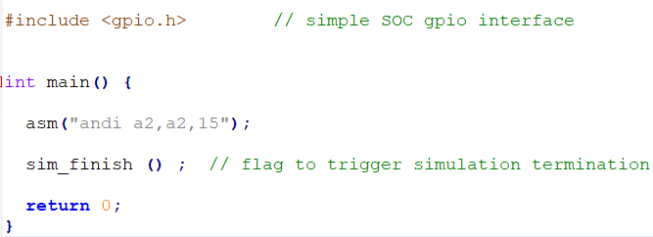

Then we compiled it and prepared for simulation. We then looked at the trace file and recognized the command there, it was one of the last commands. Notice that there a lot more commands there because of all the libraries and other boot commands. In the .elf.read file we found that it was disassembled in the main:

The trace:

To write an assembly command in hex, the format is



The specific value of the word is just an example.

1. **Debugger**
   1. Change the file:
      1. Edit $MY_PULP_APPS/sw_utils/eclipse_gdb.cmd and change the correct elf path. For example, for bubblesort:

It’s not generic, so If you want to debug another program, you’ll need to change the path.

* 1. Run the command: Our_pulp_compile bubblesort
  2. Open a second terminal on the same server.
  3. Run the command: pulp_terminal_gdb $MY_PULP_APPS/bubblesort/bubblesort.elf -x $MY_PULP_APPS/sw_utils/eclipse_gdb.cmd
  4. The gdb will now be running. For reference about the gdb commands look in $MY_PULP_ENV/misc/gdb-refcard.pdf

1. **Add files to design**

To add a file to the design, you need to make the following changes:

(the screenshots are examples of these changes in our project when we added the module riscv_custom.sv)

* 1. sim/irun/pulpino_tb.f

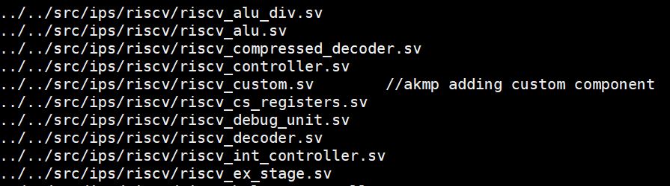

These next two files we changed for the core, so if you do the same with the rest of the SoC we are not sure that it will still work, you’ll need to check this.

* 1. src/ips/riscv/verilator-model/Makefile

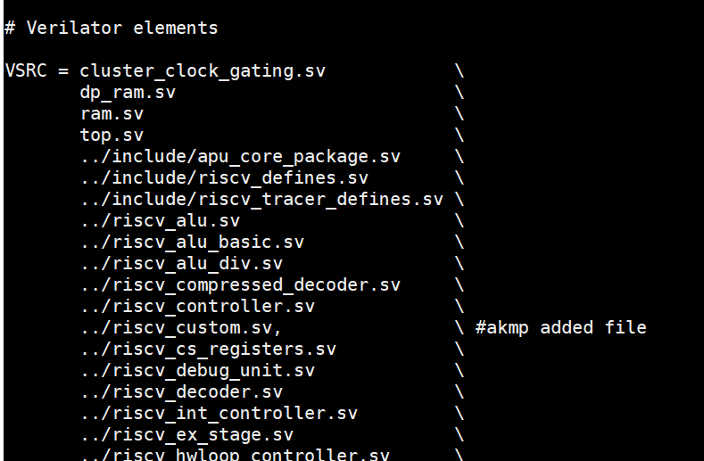

* 1. src/ips/riscv/src_files.yml

